Open Jenkins and create a Maven project using it.

Created CICDpipeline job as below.

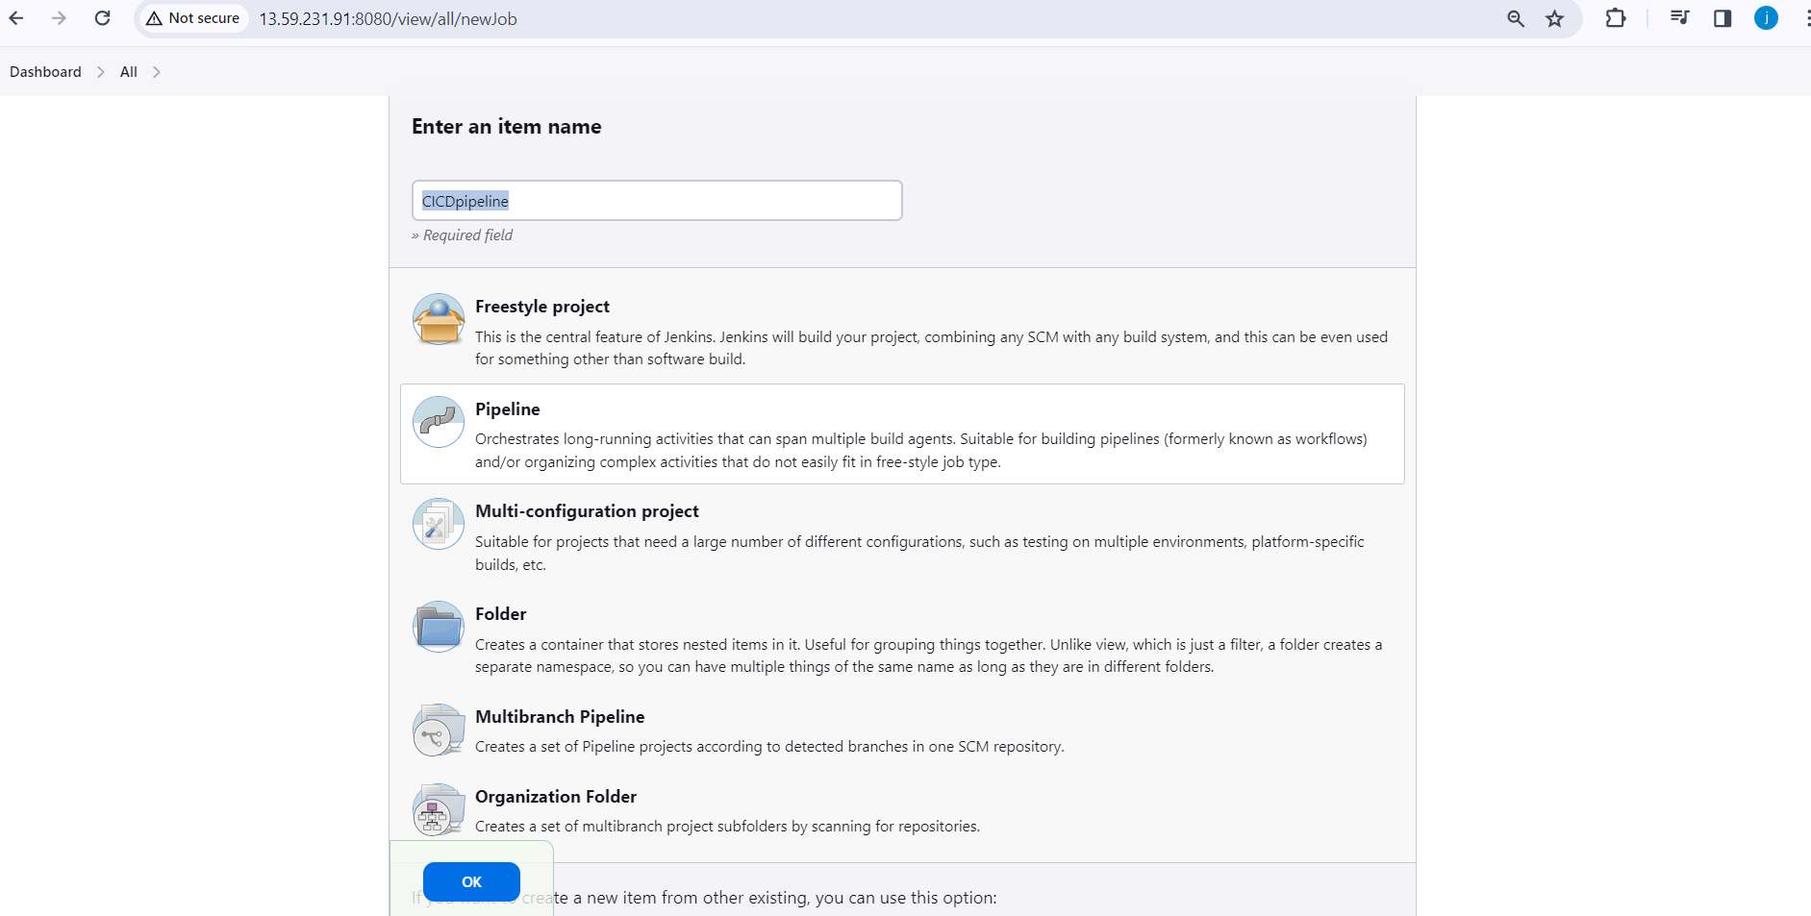

You will have to create the following jobs, which are as follow:

1 Compile

2 Code Review

3 Unit test

4 Package

5 Deploy

pipeline {

tools {maven 'mymaven'}

agent any

stages {

stage ('Clone Repo') {

steps {

git 'https://github.com/vjdgithub/DevOpsCodeDemo.git'

}

}

stage ('Compile Code') {

steps {

sh 'mvn compile'

}

}

stage ('Review Code') {

steps {

sh 'mvn pmd:pmd'

}

}

stage ('Test Code') {

steps {

sh 'mvn test'

}

}

stage ('Package Code') {

steps {

sh 'mvn clean install package'

}

}

stage ('Copy the War file from target directory to current diroctory') {

steps {

sh 'cp /var/lib/jenkins/workspace/CICDpipeline/target/addressbook.war .'

}

}

stage ('Build Image') {

steps {

sh 'docker build -t myappjenkins .'

}

}

stage ('Deploy the Image') {

steps {

sh 'docker run -d -P myappjenkins'

}

}

}

}

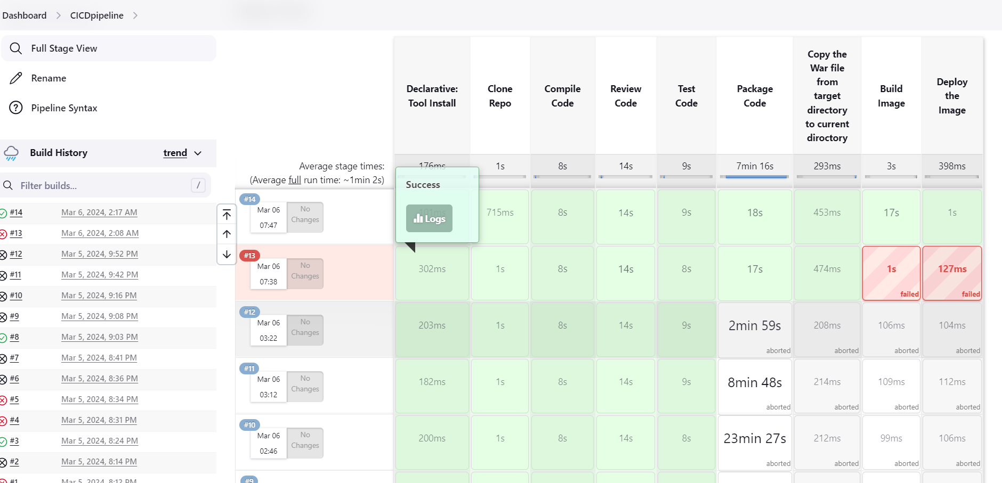

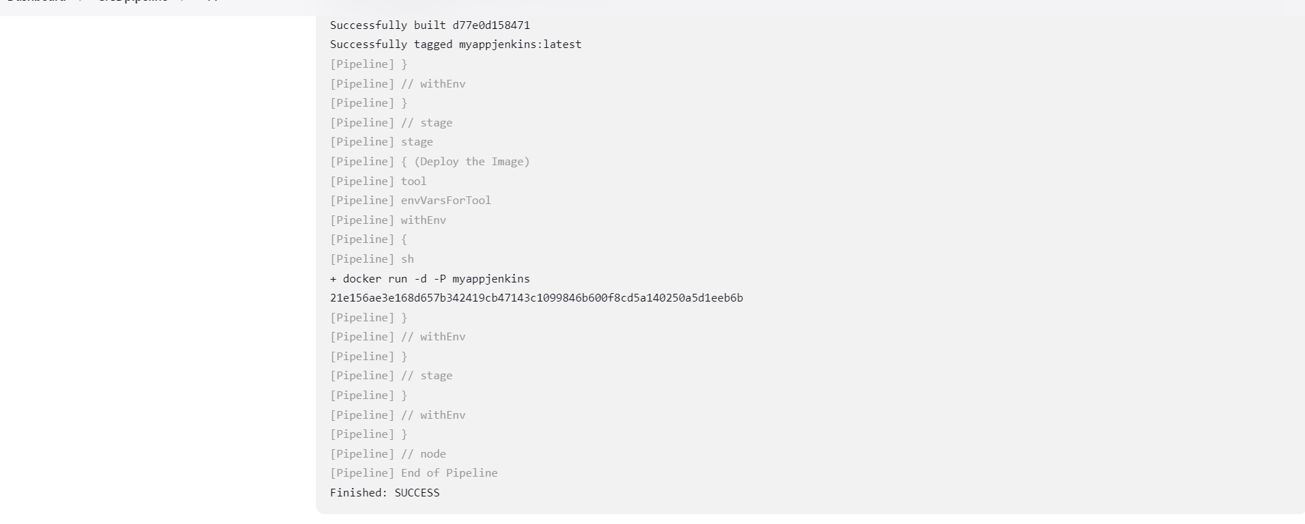

Application is accessed by url

http://18.190.239.255:32768/addressbook/